Design Document: Planet V-PET

Brief intoduction to game:

Planet managerial v-pet

Core game loop (Hooked model)

Reward: Wealth from minerals, faith

Action: Fling astriods with a swipe , Collect faith with a tap

External trigger: Notification of inpending astriods, faith collections.

Internal trigger:

Investment: Spending faith on upgrades and population.

Things that generate over time

* Population grows in accordance with the population that is already there
* Faith grows in accordance with the population and wealth. Heavily weighted towards wealth

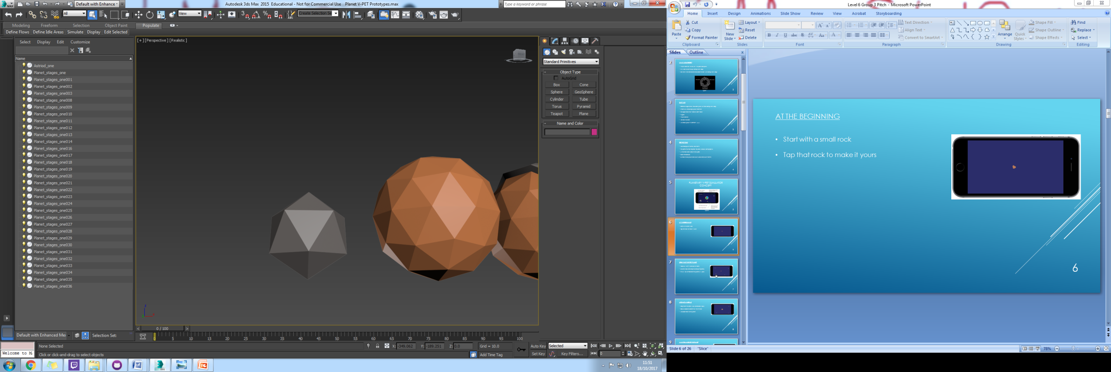Asteroids

Constantly going across the screen in small amounts. Upon recieving a notification many will appear

Players can swipe the asteroids into different trajectories to send them away from or into the planet as the player wishes. At the beginning of the game the asteroids build mass on the planet as a tutorial. Asteroids will be different shapes and sizes and the size of the planet depends of the size of the asteroids that collide with it. Also some of them can contain a range of different minerals to add wealth to the planet when the asteroids hit they take away some of the planets population.

Larger asteroids can appear when a player gets a notification that the player must tap at which point they break up into several normal asteroids to be used as above.

Faith

Faith is generated over time based slightly off the population and mostly off the wealth of a planet. And can be spent on the following.

* Small Population Boost
* Prosperity, boost to faith production
* Fertility, boost to increase population generation

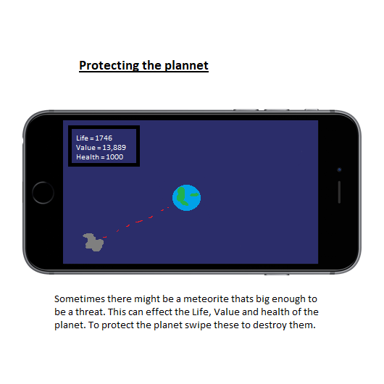

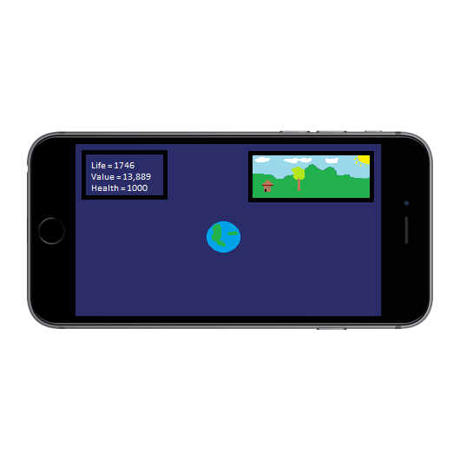

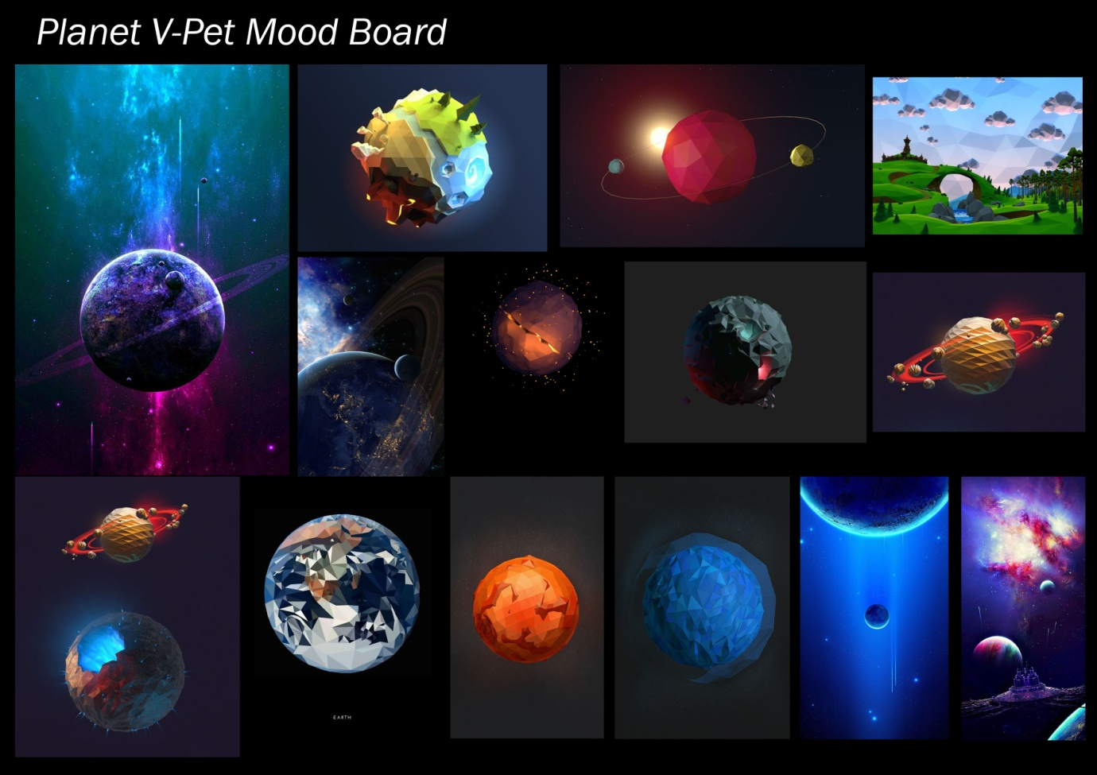Art style

Mockups

